# Case Study 1: MVC Model for a Web Application

Description:

The Trenz platform uses the Model-View-Controller (MVC) architecture provided by Laravel.

Tools/Techniques:

* Laravel MVC Framework
* Blade for Views
* Eloquent ORM for Models

Diagram included: MVC flow

# Case Study 2: Client-Server Model for a Web-Based Application

Description:

Trenz is a web-based application where the client (browser) communicates with the server (Laravel backend).

Tools/Techniques:

* HTTP/HTTPS Protocol
* Apache/Nginx Web Server
* MySQL Database

Diagram included: Client-Server Architecture

# Case Study 3: Use Case Diagram & Class Diagram for Product Purchase

Use Case Activities:

* User: Browse Products, Add to Cart, Checkout, View Orders
* Admin: Manage Products, View Sales Reports

Class Diagram contains classes: User, Product, Order, Cart with relationships.

Tools/Techniques:

* Mermaid.js for diagrams
* Laravel Eloquent for relationships

# Case Study 5: Sample Gantt Chart for Project

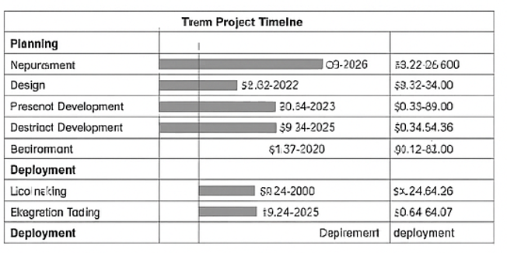

Description:

A sample Gantt chart for the Trenz project phases, covering planning, development, testing, and deployment.

Tools/Techniques:

* Microsoft Project (for actual Gantt)
* Mermaid.js for documentation

# Case Study 6: ER Diagram for Trenz Database

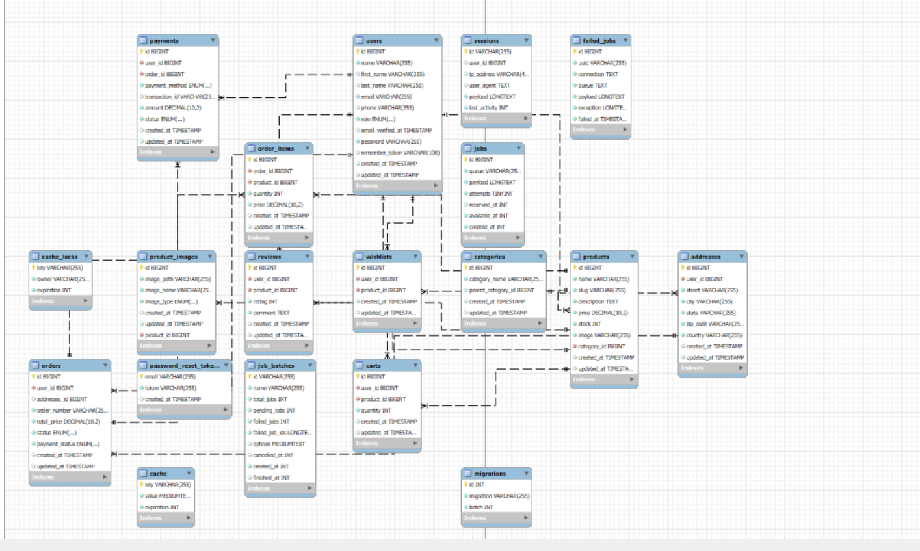

ER Diagram:

* USER, ORDER, CART, PRODUCT, WISHLIST, ORDER_ITEM, CATEGORY relationships

Tools/Techniques:

* Mermaid.js for ER diagram
* MySQL Workbench (for DB design)

# Case Study 7: Sample Interface Designs

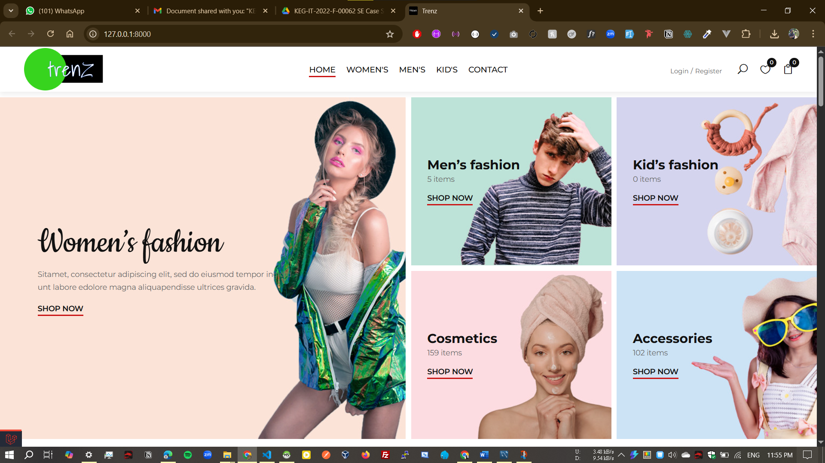



Desktop UI:

* Navigation bar, product grid, sidebar filters, cart sidebar

Mobile UI:

* Hamburger menu, product list, floating cart button

Web UI:

* Responsive product grid, search bar, user profile dropdown

Tools: Figma, Balsamiq, Adobe XD

# Case Study 8: Test Case Sample

Test Cases table listed below:

|  |  |  |  |
| --- | --- | --- | --- |
| **Test Case ID** | **Description** | **Steps** | **Expected Result** |
| TC-001 | Add product to cart | 1. Login 2. Browse 3. Add  1. Add to cart 2. Checkout  1. Go to login 2. Wrong pa | Product in cart |
| TC-002 | Checkout with valid info | Order placed |
| TC-003 | Login with invalid creds | ssError message shown |

# Case Study 9: Software Cost Calculation (COCOMO)

Assumptions:

* Project size: 10 KLOC (thousand lines of code)
* Organic mode: Effort = 2.4 × (KLOC)^1.05

Calculation:

Effort = 2.4 × (10)^1.05 ~= 2.4 × 11.22 ~= 26.93 person-months

# Case Study 10: About GitHub and Main Activities/Commands

GitHub is a platform for version control and collaboration using Git.

Main Activities:

* Code hosting, Collaboration, Code review, CI/CD integration

Common Commands:

* git clone <repo-url>, git status, git add ., git commit, git push, git pull, git branch, git checkout

Tools:

* Git CLI, GitHub interface, VS Code Git integration